Use Case Diagram

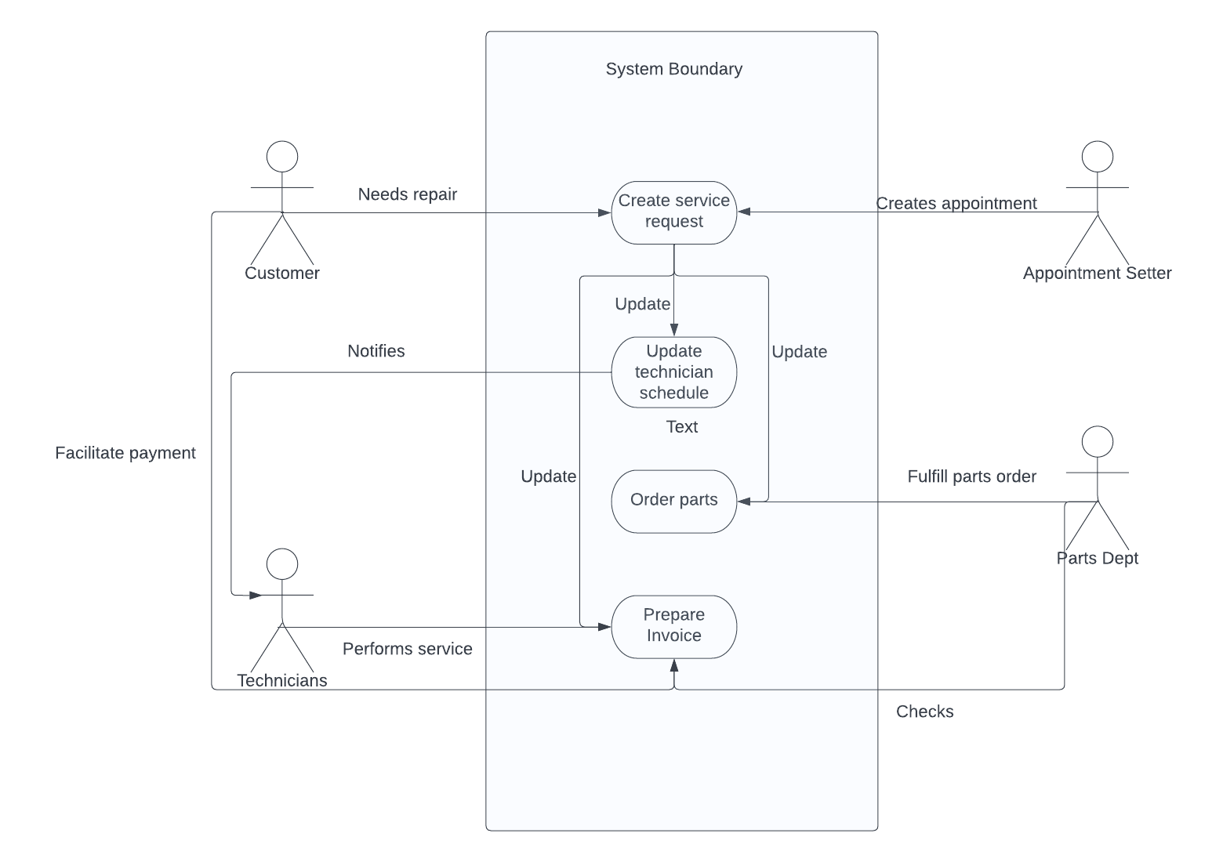

Object Modeling

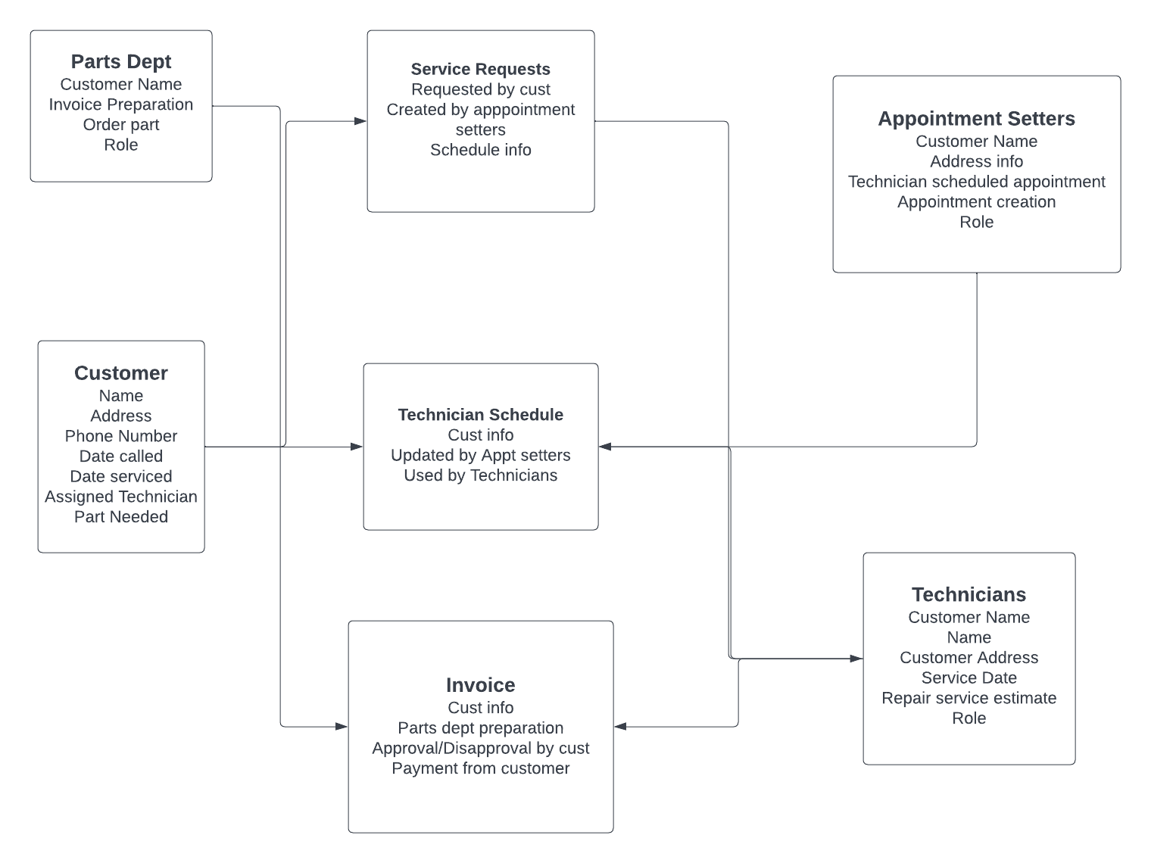

Instance Examples

|  |  |  |  |  |  |  |
| --- | --- | --- | --- | --- | --- | --- |
| **Customer** | **Date called** | **Date of service** | **Address** | **Phone** | **Technician assigned** | **Parts needed** |
| Sophie Goldberg | 1/6/2022 | 1/6/2022 | 123 Main St, Hopkinton, MA | 508-555-1256 | Robles | KN-1256 |
| Mitch Chu | 1/6/2022 | 1/7/2022 | 5525 Winter Rd, Medford, MA | 617-555-9898 | Wong | WP-1788 |
| Jamie Fernandez | 1/7/2022 | 1/7/2022 | 2 Hope St, Hull, MA | 617-555-4125 | Henson | WP-8877 |
|  |  |  |  |  |  |  |
| **Parts Dept** | **Role** | **Customer Name** | **Invoice Preparation** | **Part Ordered** |  |  |
| Rhonda Patel | Service equipment and parts | Sophie Goldberg | N/A | KN-1256 |  |  |
| Maddox Farley | Parts Director | Mitch Chu | N/A | WP-1788 |  |  |
| Celia Martel | Parts Purchasing | Jamie Fernandez | N/A | WP-8877 |  |  |
|  |  |  |  |  |  |  |
| **Technician** | **Role** | **Customer name** | **Customer Address** | **Service Date** | **Repair service estimate** |  |
| Liam Henson | Technician | Jamie Fernandez | 2 Hope St, Hull, MA | 1/7/2022 | N/A |  |
| Mark Robles | Technician | Sophie Goldberg | 123 Main St, Hopkinton, MA | 1/6/2022 | N/A |  |
| Lee Wong | Technician | Mitch Chu | 5525 Winter Rd, Medford, MA | 1/7/2022 | N/A |  |
|  |  |  |  |  |  |  |
| **Appointment Setters** | **Role** | **Customer Name** | **Address Info** | **Technician Scheduled appointment** |  |  |
| Emily Johns | Service Mgr | Jamie Fernandez | 2 Hope St, Hull, MA | 1/7/2022 |  |  |
| Lisa Shields | Appt Setter | Sophie Goldberg | 123 Main St, Hopkinton, MA | 1/6/2022 |  |  |
| Jake Meyers | Appt Setter | Mitch Chu | 5525 Winter Rd, Medford, MA | 1/7/2022 |  |  |